PROBLEM 1

PYTHON

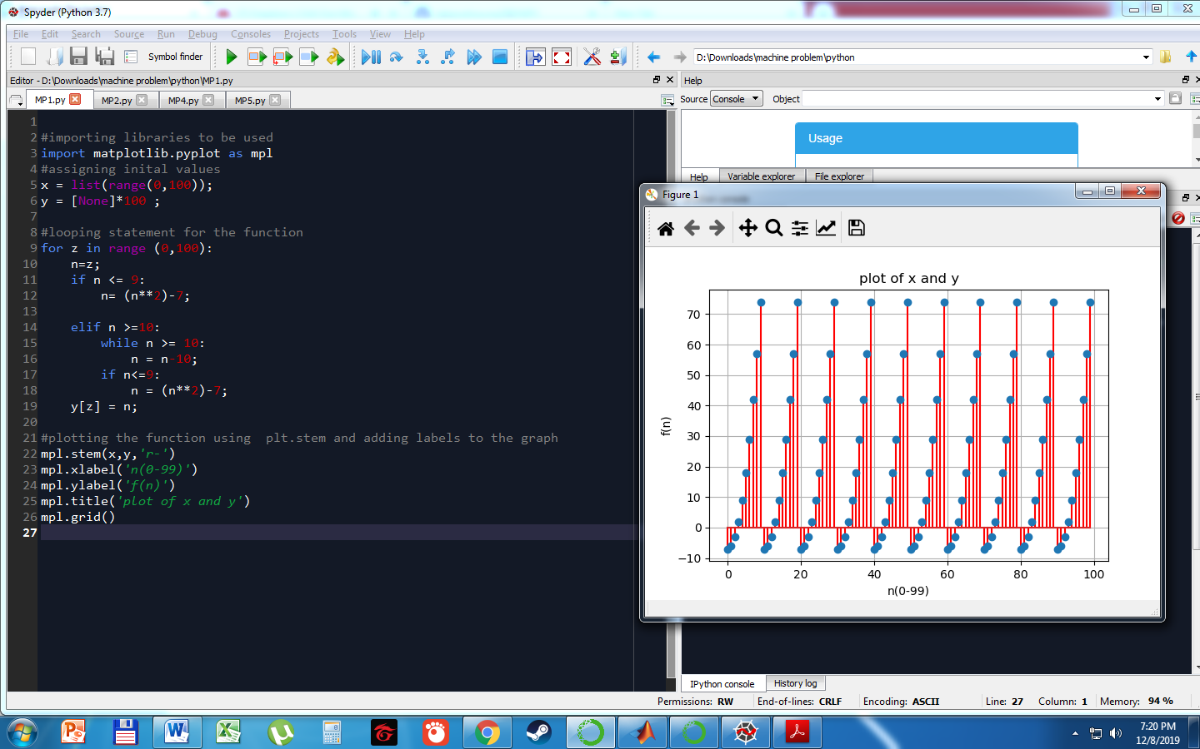

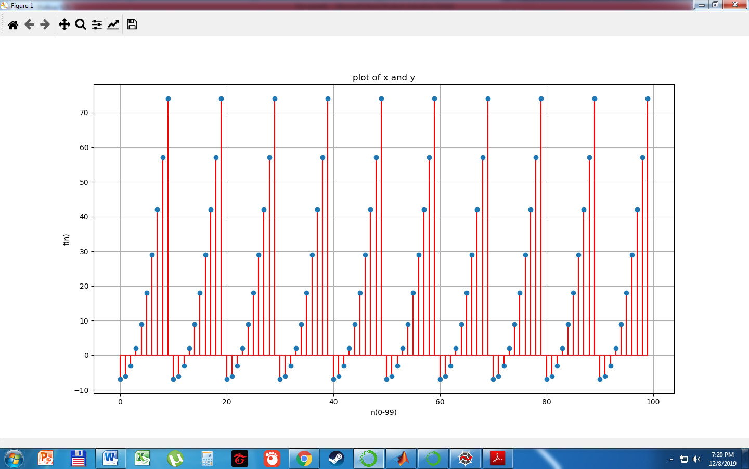

The graph only has 9 y-axis values from -7 to 74. If n= 0 to 2, they have a negative y values while n=3 to 9 have positive y values ranging from 2 to 74. If n>=10, n is decreased by ten according to the piecewise function and therefore repeating the y values to -7 at n=10 repeating until it reaches n = 99.